Lab Report

Date: April 29th ,2026
Team: E1
Team Members
Last name | First name | Email
Rahman | Md Mahbubur | md-mahbubur.rahman@stud.hshl.de
Sakib | Md Naimur Rahaman | md-naimur-rahaman.sakib@stud.hshl.de
Xu | Yongyu | yongyu.xu@stud.hshl.de
Koluacik | Baris | baris.koluacik@stud.hshl.de

Goal
Preliminary discussion of an autonomous vehicle's design and assembly, and production of preliminary design drawings for each component.
Discussion
We performed a preliminary assembly of every components and confirm the general placement of each part in the lab. As shown in the figure 1.
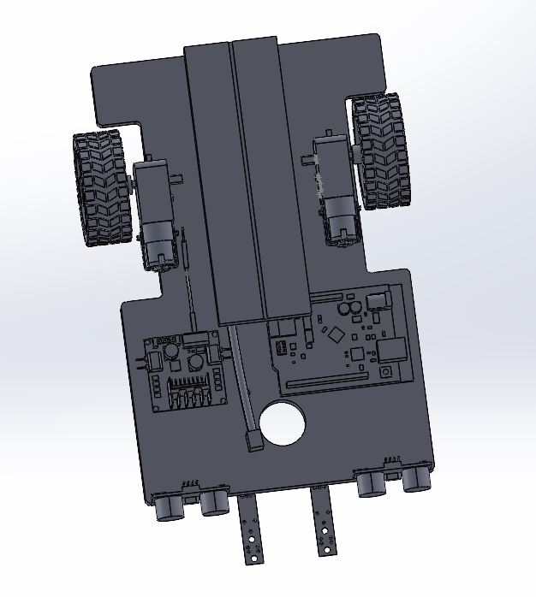
Figure 1:assembly of every components
- IR-Sensors & Ultrasonic-Sensors
According to the experiment requirements, we need to design and construct an autonomous vehicle that can follow a line, detect and avoid obstacles.
Therefore, the IR-sensors and ultrasonic-sensors must be placed at the very front of the chassis in the vehicle’s forward direction.
To maximize the detection area of the ultrasonic-sensors, we decided to place them at opposite ends of the chassis.
As for the IR-sensors used to detect the line and obstacles, to improve the accuracy of both sensors, we decided to place them between the two ultrasonic-sensors.
- Motors with tires
Since the ball bearing front wheel will rest directly on the ground and the distance between the chassis and the ground is close, we decided to place the motor on the chassis to maintain balance.

- Battery & Breadboard
Since the battery is quite heavy, we believe placing it between the motors will improve the vehicle’s maneuverability. If we placed them at the front, it might increase the resistance on the wheels as they move forward.
- Motor controller & Arduino
They will be placed in the remaining space, which is between the sensors and the battery.
Result
We measured the length, width, and height of each components in SolidWorks.
We are going to design Motor holder, IR-Sensor holder, Ultrasnic holder and bettery holder. As shown in the file, we will check their feasibility with the professors in the next lab.

